**Content-Based Recommendation Systems**

Suggest items that are similar to the ones the user has previously shown interest in. For example, if a user frequently engages with articles related to finance, the system will recommend more finance-related content. This can include explicit feedback and based on this data, the system generates a **user profile**, which is then used to find items that closely match the user's preferences. As time passes, the user continues to interact with the system which results in more accurate and relevant suggestions.

**Components of a Content-Based Recommender**

**1. User Profile**

The User Profile is a representation of the user’s preferences. We model it as a feature vector, capturing characteristics of items the user liked or interacted with.

* A **utility matrix** is used to represent interactions between users and items.
* The system analyzes items previously rated or liked by the user to identify key features like genre, actors, etc.
* These features are then aggregatedto form the user's profile vector.

**Example**: If a user likes action movies directed by Christopher Nolan and starring Christian Bale, their profile may have high weights for the features “action” “Christopher Nolan” and “Christian Bale”

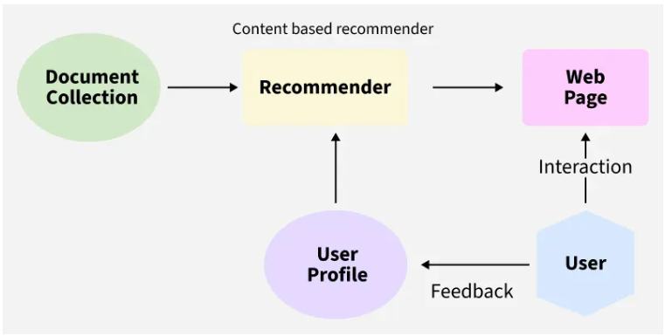

**2. Item Profile**

Each item is also represented as a vector of relevant features.Key features depend on the domain:

* **Movies:** genre, director, actors, release year, IMDb rating.
* **Books:** author, genre, publication year, keywords.
* **Products:** brand, category, specifications, price.

The item profile captures the essence of what the item is about. This information is later compared with the user profile to measure similarity.

**3. Utility Matrix**

The Utility Matrix represents the preferences of users for different items. Each row corresponds to a user and each column corresponds to an item. The matrix can be partially filled, as users rarely rate or interact with all available items.

| **User / Movie** | **Inception** | **The Dark Knight** | **Interstellar** | **The Notebook** |
| --- | --- | --- | --- | --- |
| **User A** | 5 | 4 | 5 | 1 |
| **User B** | 4 | 5 | ? | ? |

Some of the columns are blank in the matrix that is because we don’t get the whole input from the user every time, and the goal of a recommendation system is not to fill all the columns but to recommend a movie to the user which they will prefer.

**Making Recommendations**

Once the user and item profiles are created the system must determine how well each item aligns with the user's preferences. Two common approaches are:

**Method 1: Cosine Similarity**

Cosine Similarity is used to measure the angle between the user vector and the item vector. The smaller the angle (closer to 0), the higher the similarity.

**How it works:**

* A user vector might include positive weights for preferred features (e.g., genres, actors) and negative weights for disliked features.
* The cosine of the angle between vectors indicates how closely an item matches the user’s taste.

**Formula:**

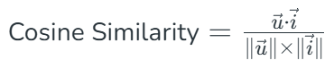

Where:

* u⃗ is the user profile vector
* i⃗ is the item profile vector

A higher similarity score indicates a better match and such items are recommended to the user.

### Disadvantages of Content-Based Recommendation Systems

While content-based systems can be quite powerful, they do have a few disadvantages:

**1. Limited Novelty**: Content-based systems tend to recommend items that are very similar to what the user has already interacted with, which can lead to a lack of diversity in recommendations. The system might not suggest new topics or genres, limiting exploration.

**2. Cold Start for Content:** If new content is added, it might not get recommended right away because the system relies heavily on understanding the content features.

**3. Feature Engineering Dependency:** The quality of the recommendations depends on how well the system captures the features of the content. Poorly engineered content features could lead to inaccurate recommendations.

**4. Over-specialization:** The system might become too narrow in its recommendations by always suggesting similar content, potentially making the user’s experience monotonous.